Ahmad Habibie Marjan

18222082

**Lembar Kerja Praktikum 0**

**IF2140 Pemodelan Basis Data**

***Deadline:* Kamis, 21 September 2023 21.40 WIB**

1. **Soal**
2. Tampilkan keseluruhan isi **tabel city**!

|  |  |
| --- | --- |
| Query | select * from city; |
| SS |  |

1. Tampilkan semua nama negara yang terdapat pada **tabel country**!

|  |  |
| --- | --- |
| Query | select name from country; |
| SS |  |

1. Tampilkan keseluruhan **tabel city** yang memiliki **CountryCode ‘BEL’**!

|  |  |
| --- | --- |
| Query | select * from city where countrycode=‘BEL’; |
| SS |  |

1. Tampilkan keseluruhan **tabel countrylanguage** yang memiliki **language ‘German’**!

|  |  |
| --- | --- |
| Query | select * from countrylanguage where language=‘German’; |
| SS |  |

1. Tampilkan semua **region (tanpa pengulangan)** dari **tabel country**!

|  |  |
| --- | --- |
| Query | select distinct region from country; |
| SS |  |

1. **Skema Basis Data**

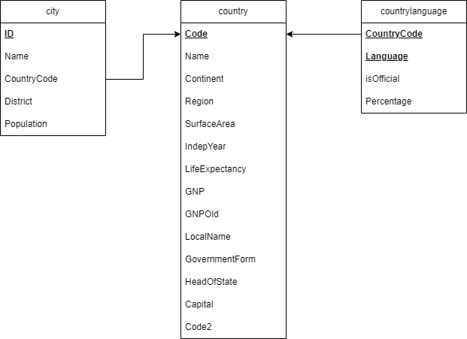

|  |
| --- |
| city = (**ID,** CountryCode, District, Population)  country = (**Code,** Name, Continent, Region, SurfaceArea, IndepYear, Population, LifeExpectancy, GNP, GNPOld, LocalName, GovernmentForm, HeadOfState, Capital, Code2)  countrylanguage = (**CountryCode, Language,** IsOfficial, Percentage) |

# 